**NATIONAL INSTITUTE OF TECHNOLOGY SILCHAR**

**Cachar, Assam**

**B.Tech. IVth Sem**

**Subject Code:** CS215

**Subject Name:** Signals and Data Communication

**Submitted By:**

Name : Subhojit Ghimire

Sch. Id. : 1912160

Branch : CSE – B

1. **An audio amplifier with a nominal gain of 100 at 4 kHz is driven by a 4 kHz sine wave with a peak amplitude of 100mV. The ideal response of the amplifier would be xi(t) 10sin(800t) volts but the actual amplifier output signal x(t) is limited to a range of ±7 volts. So the actual response signal is correct for all the voltages of magnitude less than 7 volts but for all ideal voltages greater than 7 in magnitude the response is “clipped” at ±7 volts. Compute the THD of the response signal.**

**Use “subplot” to plot ideal signal, actual signal and error in the first subplot along with numerical value of signal power of ideal signal and actual signal. Also, plot fundamental signal and sum of other harmonics in the second subplot along with numerical value of signal power of the fundamental signal sum of other harmonics and THD. All plots are in time-domain.**

* **AIM: TO PLOT IDEAL SIGNAL, ACTUAL SIGNAL, ERROR AND FUNDAMENTAL SIGNAL IN A TOTAL HARMONIC DISTORTION.**

**THEORITICAL BACKGROUND:**

**Total Harmonic Distortion (THD):** If the excitation signal of the system is a sinusoid, the THD of the response signal is the total signal power in the response signal of all the harmonics other than fundamental frequency divided by the total signal power in the response signal at the fundamental frequency.

**Ideal Amplifier:** An ideal amplifier has infinite input impedance, zero output impedance, and a fixed gain at all frequencies.

**METHODOLOGY:  
1.** In the generated ideal signal, all the values greater than 7 and smaller than -7 are replaced.  
**2.** The fundamental frequency is calculated using Fourier Transform.  
**3.** Two new variants of Fourier Transform- one containing only fundamental harmonics and the other containing everything else- are found.  
**4.** Inverse Fourier is applied and the two resulting time domain signals are plotted.  
**5.** “norm” function is used to compute the power of the signals.

**CODE:**

clear all;  
clc;  
  
sampleRate = 1e-6;

timeRange = [0:sampleRate:1e-3];

idealOut = 10*sin(2*pi*8000*timeRange);

resPlt = subplot (3,1,1);

hold on;

plot (timeRange, idealOut, ‘-r’);

realOut = idealOut;

realOut (realOut > 7) = 7;

realOut (realOut < -7) = -7;

plot (timeRange, realOut, ‘-b’);

plot (timeRange, realOut-idealOut, ‘-g’);

legend ('Ideal Response', 'Real Response', 'Error');

pbaspect ([4,1,1]);

hold off;

ft = fft (realOut);

len = int32(length(ft)/2);

fundFT = ft;

fundFT (fundFT < max(ft)) = 0;

fundHarm = ifft (fundFT, 'symmetric');

harmPlt = subplot (3,1,2);

hold on;

plot (timeRange, fundHarm);

otherFT = ft;

otherFT (otherFT >= max(ft)) = 0;

otherHarm = ifft (otherFT, 'symmetric');

plot (timeRange, otherHarm);

legend('Fundamental Harmonic', 'HigherHarmonics');

pbaspect ([4,1,1]);

hold off;

fs = 1/sampleRate;

freqRange = (-len+1:len-1)*fs/(2*len);

freqRange = round(double(freqRange), 2, 'significant');

subplot (3,1,3);

ftPlt = plot (freqRange, abs(fftshift(ft)));

freqData = zeros(len,2);

freqData (:,1) = abs(ft(1:len))';

freqData (:,2) = freqRange (len:end)';

freqData = sortrows (freqData);

freqData (freqData (:,1) < freqData (4,1), :) = [];

pbaspect ([4,1,1]);

axis([0, freqRange(end)/6, -500, 4500]);

**INPUT DATA DESCRIPTION:**The sampling is taken to be 10-6, i.e., 1Mhz.  
The saturation voltage is taken to be ±7 volts.  
The time range is taken from 0 to 10-3 with the interval of 10-6.

**RESULT:**

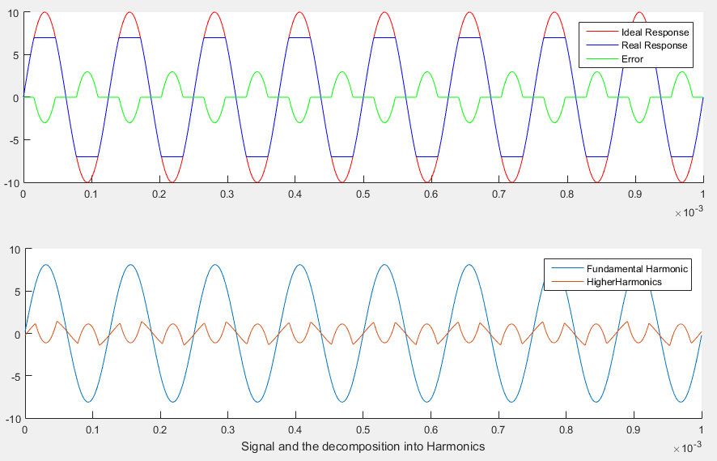  
  
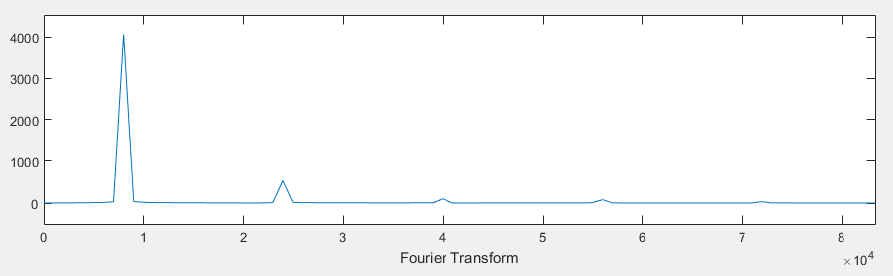  
**CONCLUSION/DISCUSSION:**

The fundamental harmonic contains most of the power of the real response. The amplitude in Fourier Transform can be interpreted as the power contained by that frequency.

In the signal and the decomposition into Harmonics graph,  
Ideal signal = 49.95  
Real Signal = 33.54

Fundamental Harmonic = 32.9239

Other Harmonics = 0.6247  
Therefore, $$THD= \frac{Power of higehr harmonics}{power of fundamental harmoics}= \frac{0.6247}{32.9239} 100\%=1.89\%$$